Inside this issue:

Water Meter Rates 1

Water Bill Calculation 1

NO PARKING on Pits 2

DOG Requirements 2

Flood Mapping 3

Garbage Rates 3

Clean YOUR Block 3

109 N Smith Ave, Kenesaw – (402) 742-3222

# **Water Bill Calculation Chart** **Taxes not included**

***Base Rate***

Residential - $17.50

2” Commercial – $59.50

3” Commercial – $83.50

***Metered Usage Rate***

$0.145 per 100 gal

and/or

$1.45 per 1000 gal

**1000’s Used** **Monthly Fee**

0 $17.50

1 $18.95

2 $20.40

3 $21.85

4 $23.30

5 $24.75

6 $26.20

7 $27.65

**1000’s Used** **Monthly Fee**

8 $29.10

9 $30.55

10 $32.00

11 $33.45

12 $34.90

13 $36.35

14 $37.80

15 $39.25

**1000’s Used** **Monthly Fee**

16 $40.70

17 $42.15

18 $43.60

19 $45.05

20 $46.50

FEBRUARY 16, 2017

# **WATER RATES**

**NOTICE TO RESIDENTS**



## VILLAGE OF KENESAW

The Village of Kenesaw Board of Trustee’s and Superintendent would like to thank all of the residents and business owners in Kenesaw for their cooperation through the process of installing the new water meters for the Village. At this point the construction portion is 99 % complete.

At the Board of Trustee’s meeting held on February 14th, 2017 the Nebraska Rural Water Association presented a water rate study for the surrounding villages which provided a water rate recommendation to the board members.

The following water rate was approved and adopted commencing on April 1, 2017.

Because utility services are billed in the month following the usage, your April 1st bill will include your meter reading for the water used in the month of March – but you will not be paying for your metered water consumption for that month. You will pay your current amount.

Billing for water consumption will begin for the water usage of April – which is billed on May 1st.

All meters, whether inside or outside, will be read through radio reading by the village staff. You will not be responsible for reading your meter or calculating your water usage. The chart below is informational only.

OR 6-401(A)- “ Any person…who violates…the provisions of this chapter… shall be deemed guilty of an offense and… shall be fined in any sum not exceeding $500.00. A new violation shall be deemed to have been committed every 24 hours of failure to comply with the provisions of this chapter.”

It has been brought to the attention of the Village of Kenesaw Board of Trustee’s that there is an increased concern regarding dogs running loose throughout the Village.

If you are a dog owner – Please be respectful of other and keep your dog contained at all times.

**OR No. 6-106** –

*It shall be unlawful for the owner of any dog to allow such dog to run at large at any time with in the* *corporate limits of the Village. It shall be the duty of the Village Police to cause any dog found to be running at large within the Village to be taken up and impounded. “running at large” shall mean any dog found off the premises of the owner and not under control of the owner or a responsible per son either by leash, cord, chain, wire, rope, cage or other suitable means of physical restraint.*

**All Kenesaw Dog Owners -**

Your Dog Tag Licenses expired on January 31, 2017

Please Contact the Village office immediately to license your dog for 2017. Proof of current rabies vaccinations is required.

*OR. No, 6-101*

**NEW Chicken/Bird Ordinance**

On Feb. 14th , 2017 the Board of Trustee’s approved a new ordinance pertaining to the keeping and housing of chickens and other like bird. For more details on this Ordinance and licensing requirements please contact the Village Clerk

# **Dog Tags Due February 1, 2017**

## NO DOGS RUNNING AT LARGE

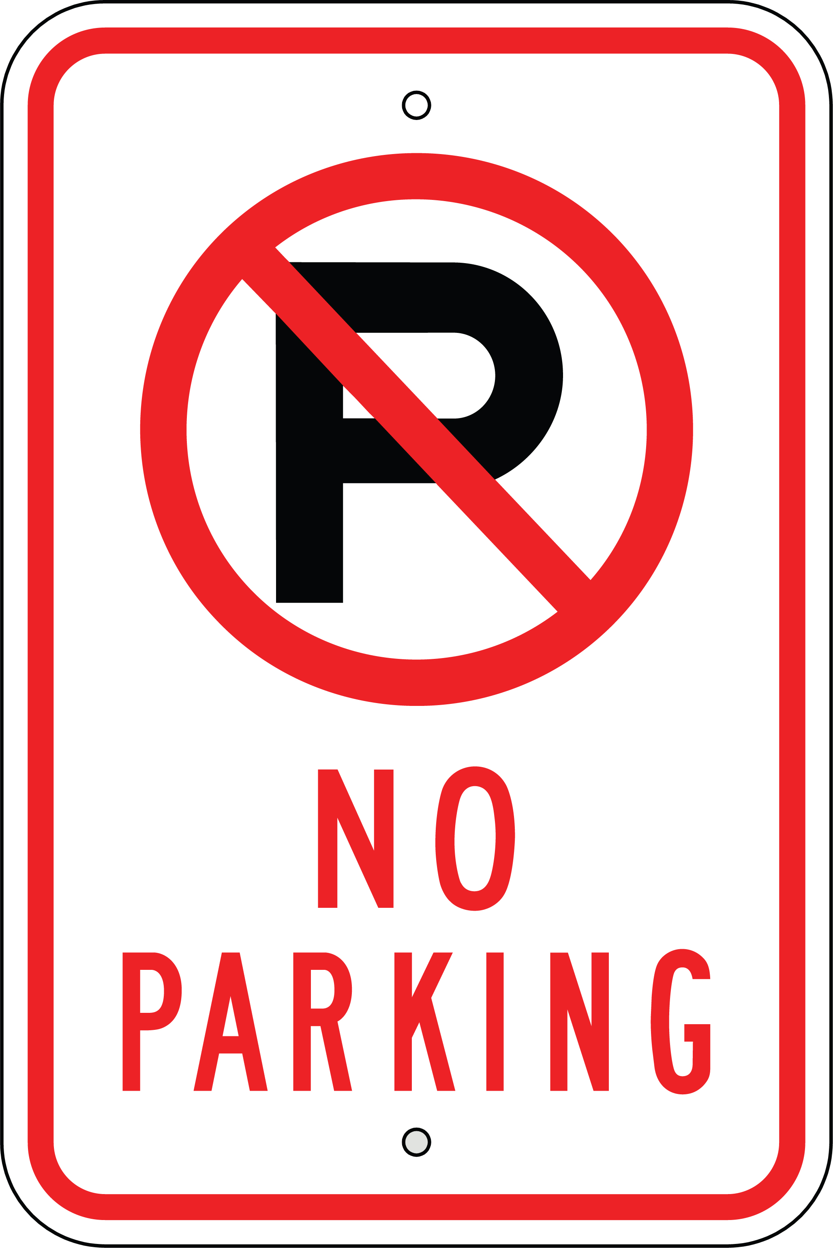

**2**

# **\*\*\*NOTICE - NO PARKING/DRIVING ON WATER METER PITS**

This notice is to serve as notice that All water-meter pits are the property of the Village of Kenesaw regardless of location, this includes pits in the Village of Kenesaw easement right of way where parking is prohibited. Damage caused to the pit in any way is the liability of the property resident and will be fixed at the property resident’s expense. Driving or parking on meter pits is prohibited and will cause the pit to break and possibly cause damage to the water line and water-meter. Any damages will be your liability.

Thank you – Village Superintendent



FRIDAY -

MAY 12th, 2017

# CLEAN YOUR BLOCK PARTY – Spring Clean-up

We all like to have a beautiful place to call home – and we all want to be proud of our community.

SO… Let’s Every One Do Our Part!!!



“Check your billing statement for your current amount due.”

As many of you are already aware, FEMA is currently working at mapping the Kenesaw area for flood hazard. There has been many meetings and much discussion with regard to how this will ultimately affect the residents of Kenesaw.

The Board of Trustee’s would like you to know that they are continuing to look into the options regarding this situation, and will continue to work to provide the best outcome for the Kenesaw residents.

We would welcome any additional research information on this project.

We have been told by the Nebraska Department of Natural Resources that the FEMA Flood Plain Maps of Kenesaw have been sent to the Federal Registrar and are awaiting processing, We are also told that this is a process that could take up to 90 days.

The Board of Trustee’s is consulting with engineering firms to see if there may be any possibility for appeal on the mapped findings.

Please feel free to stop by the Village Clerks office or talk with the Village staff or Trustee’s for more information.

The Village will bring you more information as it is available.

3



# **Flood Plain Mapping - Update**

# **Woodward Garbage Service Rate Increase**

The Woodward Garbage Service rated increased effective

February 1, 2017.

Check your billing statement for your current amount due.

*RESIDENTIAL Monthly Service*  -

Toter $13.50 per month

Extra Toter - $5.00

*Commercial Monthly Service*

Toter $13.50

Two Toters $22.50

1 Yard Con. $37.50

1.5 Yard $47.50

2 Yard $57.50

3 Yard $67.50

4 Yard $77.50

6 Yard $107.50

8 Yard $142.50